**CS 6360.501 Database Design**

**USER GUIDE**

**Search/View All**

1. To Search for any book, enter any combination of the ISBN, Book Title or Author name in the given search field.
2. Upon clicking the Search/View All button, all the values matching the given search value will be displayed in the table below.
3. From the list you can select a book to check in or check out based on the availability of the book.
4. If nothing is typed in the search field, all the entities are displayed.

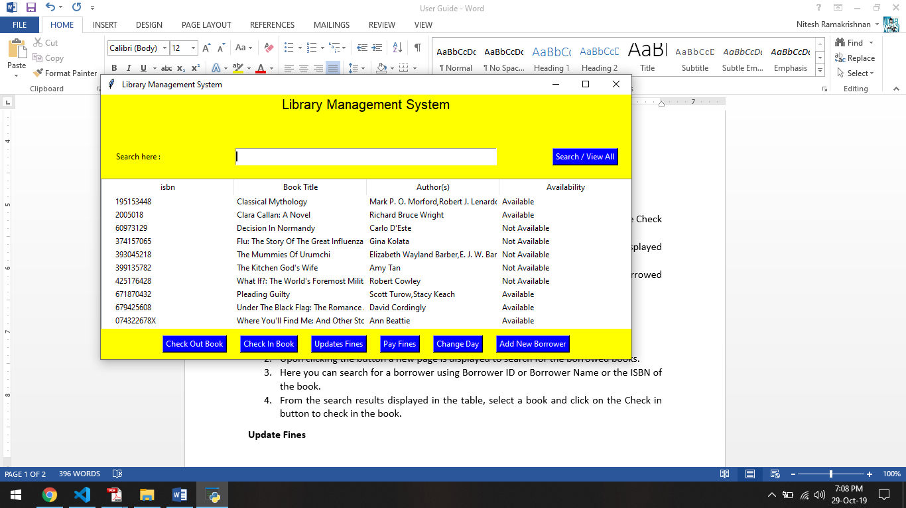

**Check Out**

1. To check out a book, you have to first select a book from the table and click on the Check Out Book button.
2. Upon clicking the button, based on the availability of the book a message box is displayed to enter the Borrower ID to check out the book.
3. An error message is displayed if the book is not available or if the borrower has borrowed already 3 books previously.

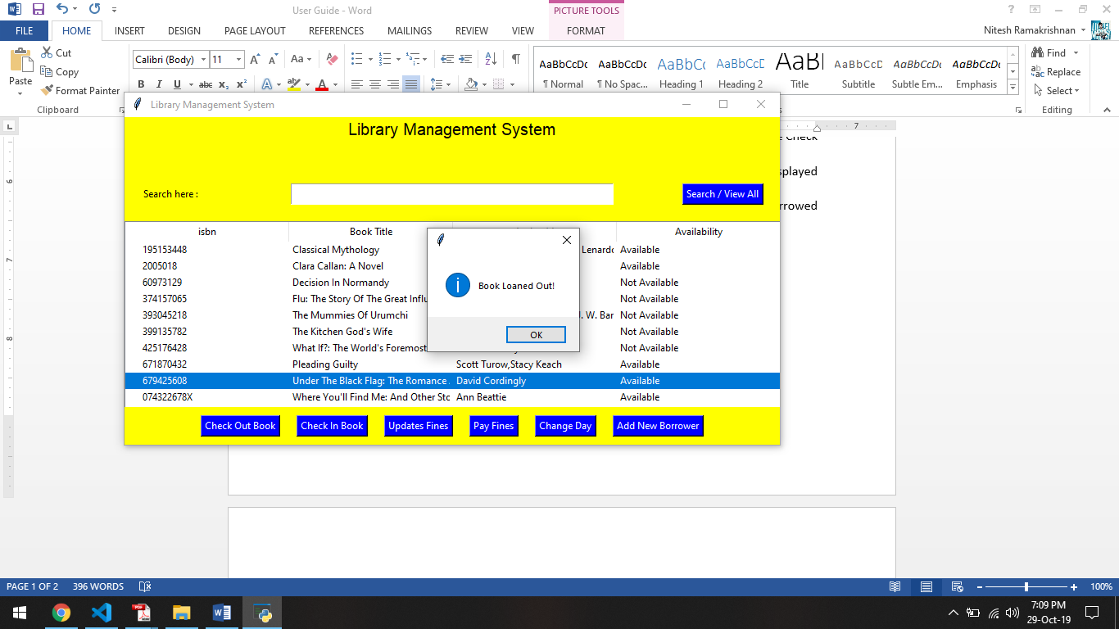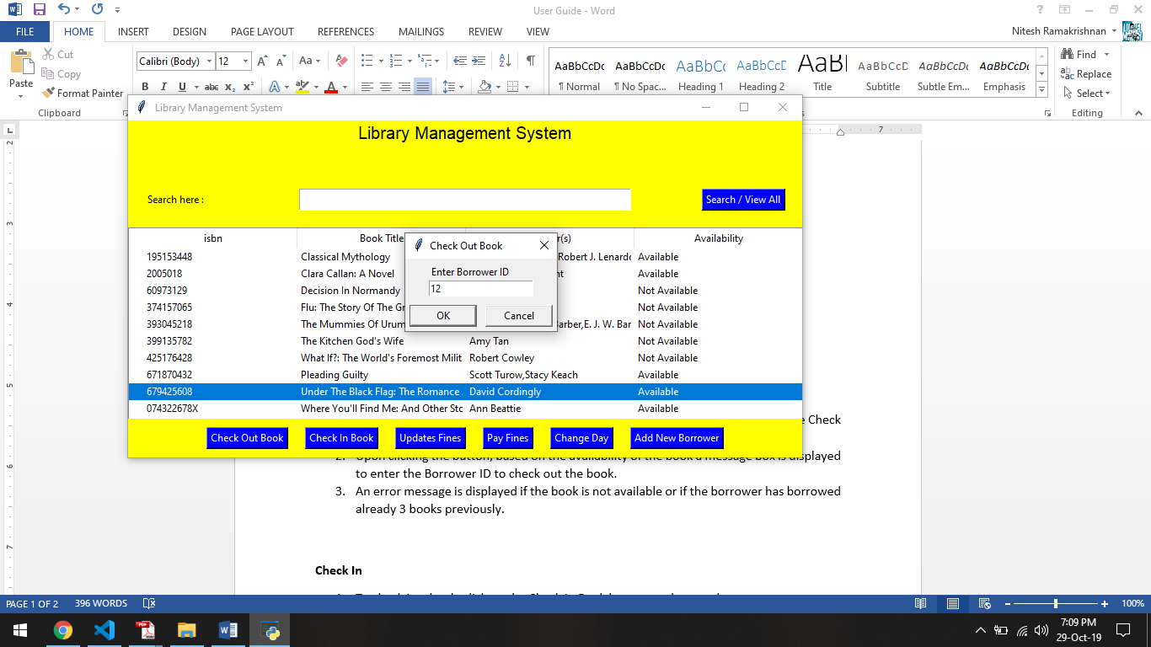

**Check In**

1. To check in a book, click on the Check In Book button on the search page.
2. Upon clicking the button a new page is displayed to search for the borrowed books.
3. Here you can search for a borrower using Borrower ID or Borrower Name or the ISBN of the book.
4. From the search results displayed in the table, select a book and click on the Check in button to check in the book.

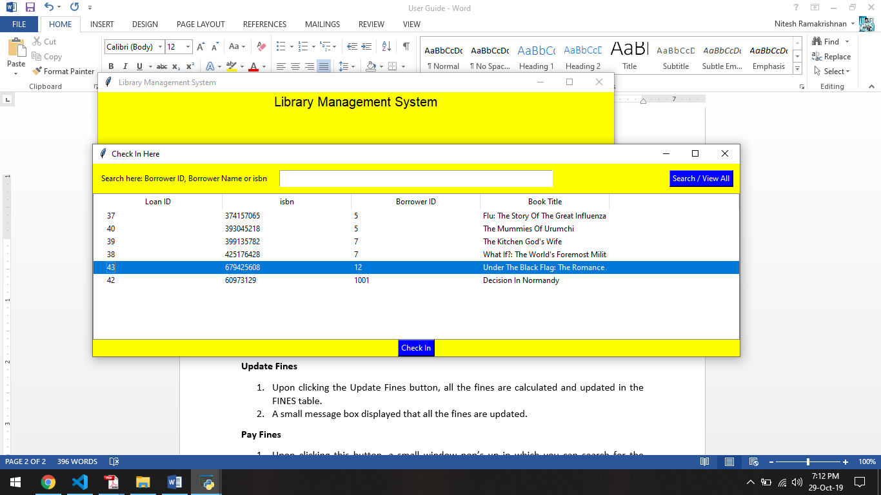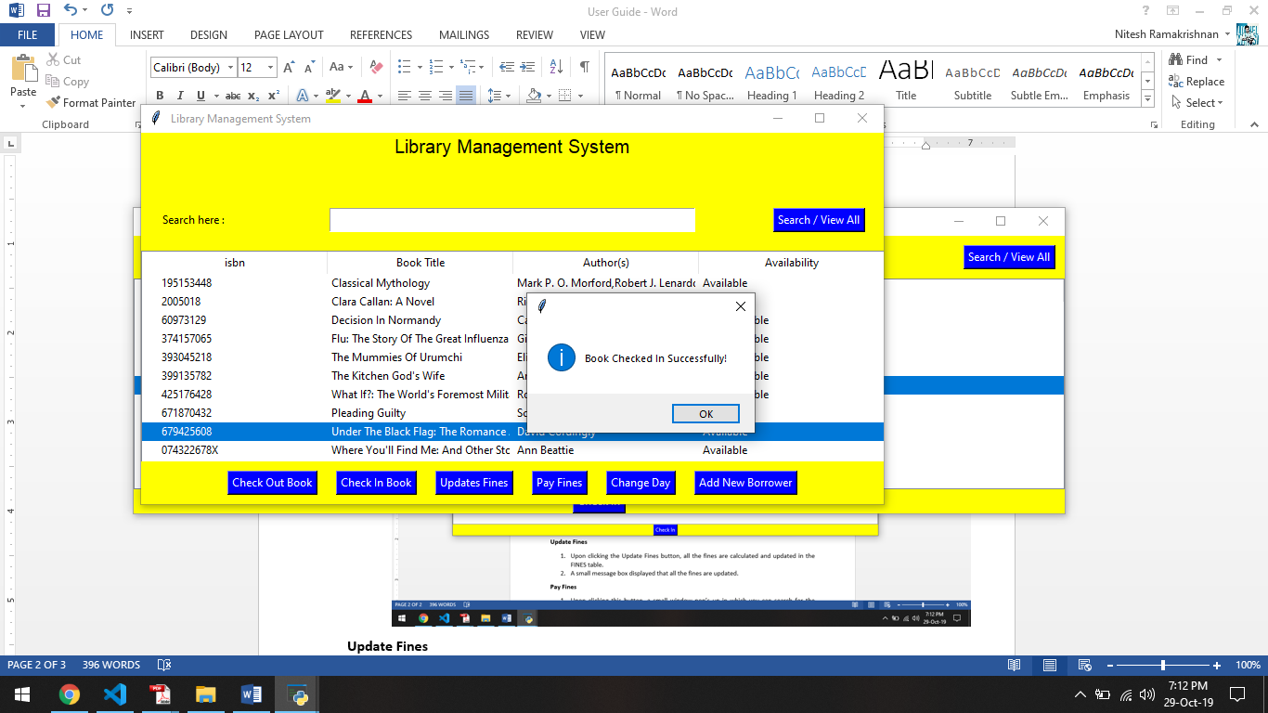

**Update Fines**

1. Upon clicking the Update Fines button, all the fines are calculated and updated in the FINES table.
2. A small message box displayed that all the fines are updated.

**Pay Fines**

1. Upon clicking this button, a small window pop’s up in which you can search for the Borrower ID to check if there are any fines to be paid.
2. Upon clicking Pay Fine button, all the fines for that Borrower ID is paid and the result is updated in the FINES table.

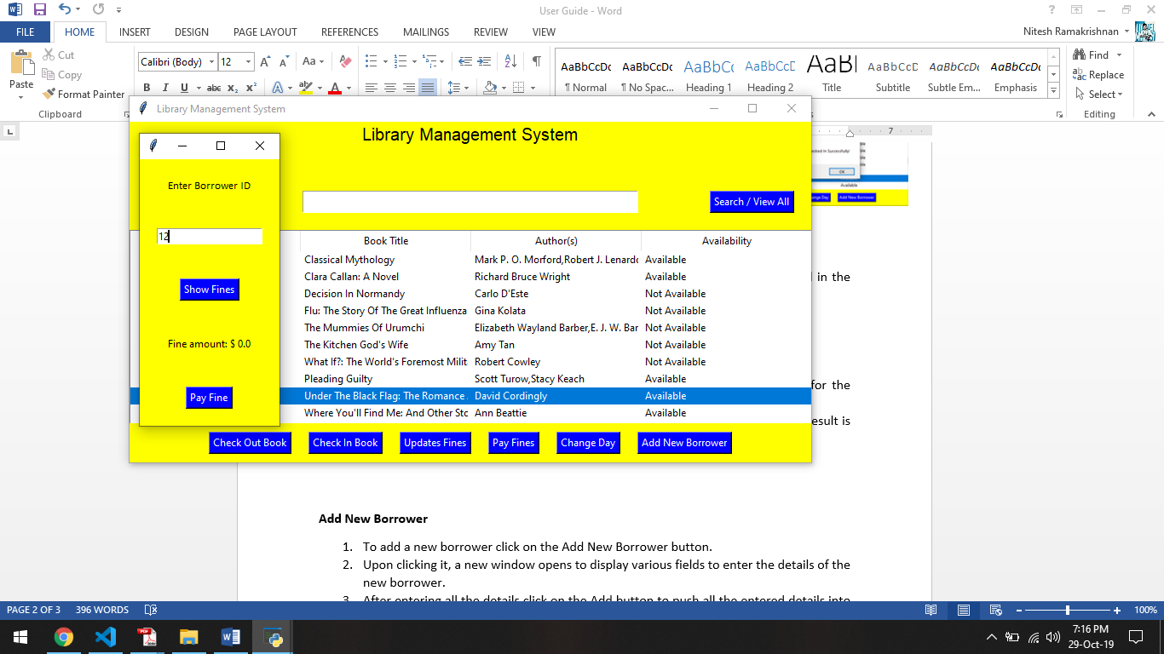

**Add New Borrower**

1. To add a new borrower click on the Add New Borrower button.
2. Upon clicking it, a new window opens to display various fields to enter the details of the new borrower.
3. After entering all the details click on the Add button to push all the entered details into the BORROWER table.

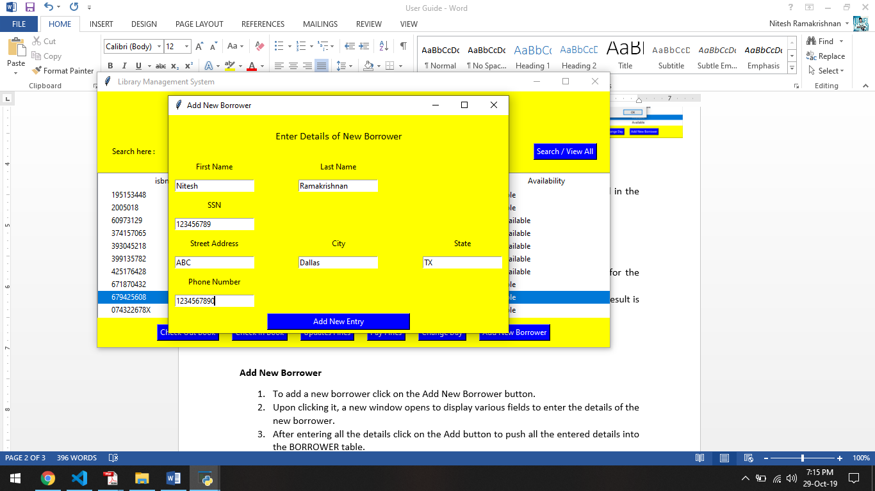

**Change Day**

1. This button is used to change the date to the next day.